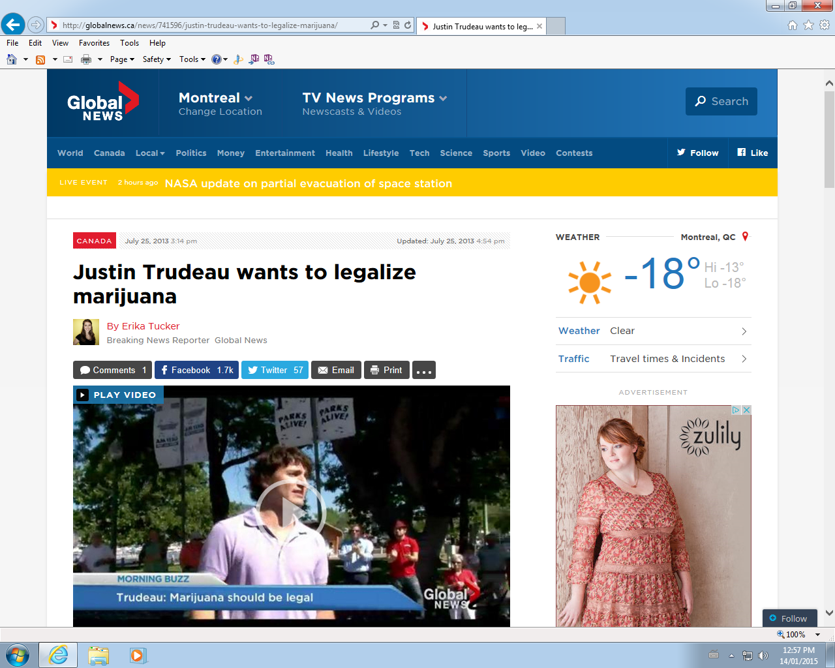

|  |
| --- |
| **Learning situation:** The next federal elections will happen sometime in 2015. You did hear on a Global Television report that Justin Trudeau, who will be a candidate for the 2015 elections, is proposing that Canada legalize marijuana. You are not sure where you stand on that topic and choose to research it further before you decide who gets your vote. |

|  |
| --- |
| **Learning situation:** The next federal elections will happen sometime in 2015. You did hear on a Global Television report that Justin Trudeau, who will be a candidate for the 2015 elections, is proposing that Canada legalize marijuana. You are not sure where you stand on that topic and choose to research it further before you decide who gets your vote.  **Read**   1. Please read the following information regarding   **Watch**   1. Please watch   **Listen**   1. Listen to the interview regarding   **Respond**   1. Write an email to Justin Trudeau |